|  |
| --- |
|  |
| 新概念 3 册 |
| Lesson48 The silent village |

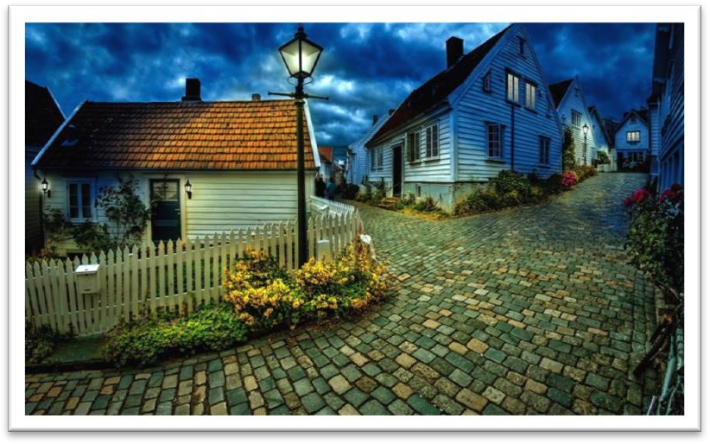

Book

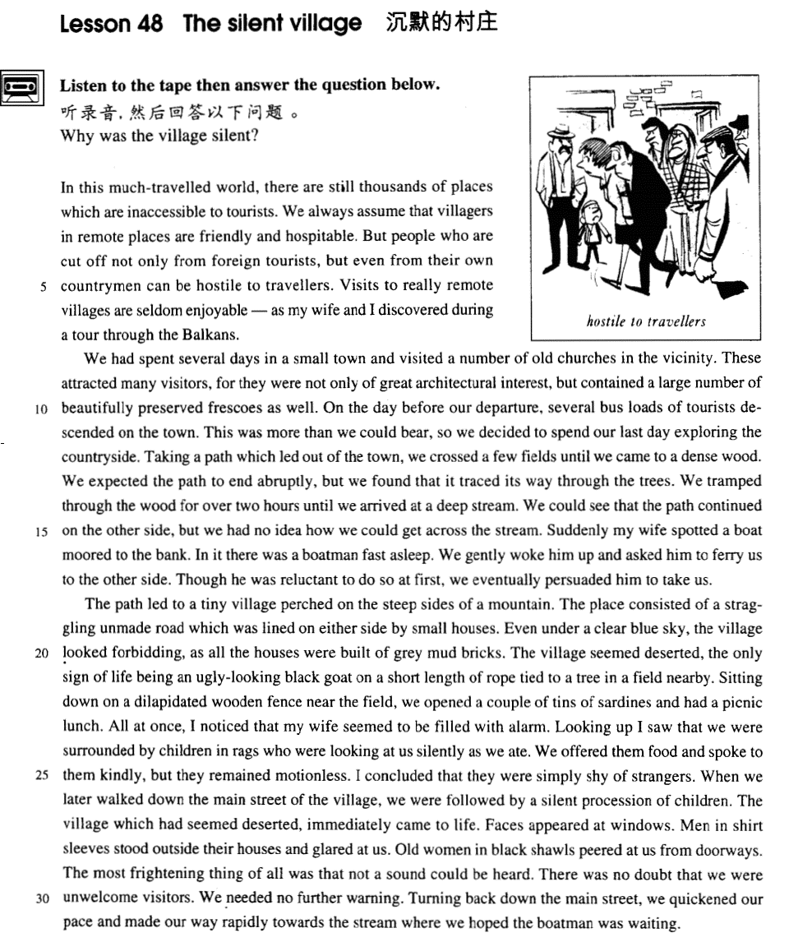

课文

In this much-travelled world, there are still thousands of places which are inaccessible to tourists.

在这个旅游频繁的世界上，仍有成千上万个游人足迹未至的地方。

We always assume that villagers in remote places are friendly and hospitable.

人们总是以为偏僻的地方的村民们热情好客。

But people who are cut off not only from foreign tourists, but even from their own countrymen can be hostile to travellers.

但是，那些不但与外国旅游者隔绝，而且与本国同胞隔绝的人们有可能对游客抱有敌意。

Visits to really remote villages are seldom enjoyable -- as my wife and I discovered during a tour through the Balkans.

到真正偏僻的村庄去旅游并不是一件愉快的事情。我与妻子在一次周游巴尔干半岛时对此深有体会。

We had spent several days in a small town and visited a number of old churches in the vicinity.

我们在一座小镇上逗留了几天，参观了附近的许多古老的教堂。

These attracted many visitors, for they were not only of great architectural interest, but contained a large number of beautifully preserved frescoes as well.

这些教堂吸引大量游客，不仅是因为建筑风格奇特，而且还有大量保存完好的壁画。

On the day before our departure, several bus loads of tourists descended on the town.

我们离开小镇的前一天，镇上来了几辆满载游客的公共汽车。

This was more than we could bear, so we decided to spend our last day exploring the countryside.

人多得使我们难以忍受，于是我们决定利用最后一天去乡间一游。

Taking a path which led out of the town, we crossed a few fields until we came to a dense wood.

我们走上了一条出镇的小路，穿过几块农田，来到一片茂密的树林。

We expected the path to end abruptly, but we found that it traced its way through the trees.

我们原以为小路会到此突然终止。没想到它到树林中继续向前延伸。

We tramped through the wood for over two hours until we arrived at a deep stream.

我们在树林中跋涉了两个多小时，到了一条深溪边。

We could see that the path continued on the other side, but we had no idea how we could get across the stream.

我们可以看到小路在深溪对岸继续向前伸展，但却不知如何越过这道深溪。

Suddenly my wife spotted a boat moored to the bank.

突然，妻子发现岸边泊着一条小船，

In it there was a boatman fast asleep.

船上有一船夫在呼呼大睡。

We gently woke him up and asked him to ferry us to the other side.

我们轻轻地把他唤醒，请他把我们摆渡过溪。

Though he was reluctant to do so at first, we eventually persuaded him to take us.

一开始，他很不愿意，但经劝说，终于同意了。

The path led to a tiny village perched on the steep sides of a mountain.

顺着小路，我们来到一个座落在陡峭山坡上的小村庄。

The place consisted of a straggling unmade road which was lined on either side by small houses.

这儿有一条未经修筑的弯弯曲曲的道路，路两边排列着一些矮小的农舍。

Even under a clear blue sky, the village looked forbidding, as all the houses were built of grey mud bricks.

农舍全用灰色的土坯建成，因此，即使在晴朗的蓝天底下，村庄看上去也会令人感到难以亲近。

The village seemed deserted, the only sign of life being an ugly-looking black goat on a short length of rope tied to a tree in a field nearby.

村里似乎无人居住，唯一的生命迹象是附近田里一只面目可憎的黑山羊，用一截短绳拴在一棵树上。

Sitting down on a dilapidated wooden fence near the field, we opened a couple of tins of sardines and had a picnic lunch.

我们在田边一堵东倒西歪的篱笆墙上坐下来，打开几听沙丁鱼罐头，吃了一顿野外午餐。

All at once, I noticed that my wife seemed to be filled with alarm.

突然，我注意到妻子十分惊恐。

Looking up I saw that we were surrounded by children in rags who were looking at us silently as we ate.

我抬头一看，发现我们被一群衣衫褴褛的小孩团团围住了，他们在默不作声地看着我们吃饭。

We offered them food and spoke to them kindly, but they remained motionless.

我们给他们东西吃，客客气气地同他们交谈，但他们却一动也不动。

I concluded that they were simply shy of strangers.

我认为这不过是他们在陌生人面前表现出的害羞。

When we later walked down the main street of the village, we were followed by a silent procession of children.

后来，我们在村里的主要街道上行走的时候，一队默不作声的孩子跟在我们后头。

The village which had seemed deserted, immediately came to life.

刚才还似乎空荡荡的村庄一下子活跃了起来，

Faces appeared at windows.

窗口露出了一张张面孔，

Men in shirt sleeves stood outside their houses and glared at us.

只穿着衬衣的男人们站在屋子外面凶狠地盯着我们，

Old women in black shawls peered at us from doorways.

披黑纱巾的老妇人站在门口偷偷地瞅着我们。

The most frightening thing of all was that not a sound could be heard.

最令人害怕的是到处没有一点声音。

There was no doubt that we were unwelcome visitors.

毫无疑问，我们的来访是不受欢迎的。

We needed no further warning.

我们不需要进一步的警告了。

Turning back down the main street, we quickened our pace and made our way rapidly towards the stream where we hoped the boatman was waiting.

便掉转身子，沿着那条主要街道加快步伐，快速地朝深溪边走去，希望船夫还在那儿等着我们。

词汇讲解

* **inaccessible** [ɪnək'sesəbl] adj. 无法到达的
* The country consists mainly of dense jungles and **inaccessible** mountain ranges.

**inaccessible *to*** 对…无法到达的

* The bathroom is situated at the top of a flight of stairs, making it **inaccessible *to*** the disabled.

**【反义词】**

**accessible** 可到达的；可接近的；可进入的；可使用的；可见到的

* The village is isolated and **accessible** only by helicopter.

**be accessible** ***to*** 对…可以到达的

* All parts of the museum are **accessible *to***wheelchairs.

**【扩展】【同根词】**

**access** n. **含义1**.（接近或进入某地的）方法，通道

**access to …** 通往…

* The only **access to** the farmhouse is across the fields.

**access** n. **含义2**.（使用某物或接近某人的）机会或权利

**have access to …** 拥有…使用/接近…的权利

* Students must **have access to** a good library.
* Only high officials **have access to** the president.
* **hospitable** ['hɒspɪtəbl] adj. 好客的

**be hospitable to / towards sb.** 对…来说很好客、热情

* The local people **are very hospitable to** strangers.

**【同根词】**

**hospitality** n. 好客；殷勤

* Thank you for your kind **hospitality**.
* The Chinese are noted for their **hospitality**.

**【反义词】**

**inhospitable** adj.不殷勤待客的；不好客的

**unfriendly** adj.不友好的；冷漠的；有敌意的

**unwelcoming** adj.（对造访者）不亲切的，不热情的，冷淡的

**forbidding** adj.冷峻的；令人生畏的

* a **forbidding** place / appearance
* The more expensive kind of antique shop where rare objects are beautifully displayed in glass cases to keep them free from dust is usually a **forbidding** place.
* **hostile** ['hɒstaɪl] ['hɑ:stl] adj. 很不友好的，有敌意的
* **hostile** attitude 敌意的态度
* a **hostile** response（回应） / reaction（反馈） / crowd（人群） / review（评论） / reception（接待） … 有敌意的…

**be hostile to / towards ...** 对…有敌意

* But people who are cut off not only from foreign tourists, but even from their own countrymen can **be hostile to** travellers.

**【近义词组】**表达“有敌意的”：

**be antagonistic to / towards ...** 【书面语】

* He'**s** always **antagonistic towards** new ideas.

**【词缀】**（构成形容词和名词）表示“能”，“倾向”，“关系”

host**ile** n. 敌对 adj. 敌对的，敌方的；怀敌意的

doc**ile** adj. 温顺的，驯服的；容易教的

fert**ile** adj. 富饶的，肥沃的；能生育的

frag**ile** adj. 脆的；易碎的

fut**ile** adj. 无用的；无效的；没有出息的；琐细的；不重要的

infant**ile** adj. 婴儿的；幼稚的；初期的

juven**ile** adj. 青少年的；幼稚的

miss**ile** adj. 导弹的；可投掷的；用以发射导弹的

ag**ile** adj. 敏捷的；机敏的；活泼的

rept**ile** adj. 爬虫类的；卑鄙的

* **vicinity** [vɪ'sɪnɪti] n. 附近地区

**in the vicinity (of sth.)** 在…的附近

* There is no hospital **in the vicinity**.
* There are several hotels **in the** immediate **vicinity of** the station.
* We had spent several days in a small town and visited a number of old churches **in the vicinity**.
* Everyone knows that if he shouts **in the vicinity of a wall** or a mountainside, an echo will come back.

**【近义词组】**表达“在…的附近”：

**in the neighborhood (of sth.)**

* Is there a good Chinese restaurant **in the neighborhood**?
* Houses **in the neighborhood of** Paris are extremely expensive.
* Hans returned to his family home, but the house had been bombed and no one **in the neighbourhood** knew what had become of the inhabitants.

**【总结】【复习】**表达“在…的附近”：

* a famous arcade **near** Piccadilly.
* a famous arcade **close to** Piccadilly.
* a famous arcade **off** Piccadilly.
* a famous arcade **in the neighborhood of** Piccadilly.
* a famous arcade **in the vicinity of** Piccadilly.

**【总结】【复习】**表达“很短的距离”：

* be only a short bus ride away 很短的距离（坐公交车就能到）
* **be only a stone’s throw away** 很短的距离（扔一块石头的距离）
* **be within walking distance**  很短的距离（走着就可以到）
* **be within driving distance** 很短的距离（开车就可以到）
* **be within commuting distance** 很短的距离（乘车往返的距离）
* **abruptly** [ə'brʌptlɪ]adv. 突然地，意外地

**【同根词】**

**abrupt** adj. **含义1**. sudden and unexpected, often in an unpleasant way 突如其来的，意外的

* an **abrupt** **ending**（结束） / **change**（变化） / **departure**（离去） 突然的
* **come to an abrupt end / halt** （出乎意料的）突然的结束
* The bus **came to an abrupt halt**.
* Our friendship **came to an abrupt end**.
* **bring sth. to an abrupt end / halt** 使某事（出乎意料的）突然的结束
* The accident **brought** his career **to an abrupt end**.

**abrupt** adj. **含义2**. seeming rude and unfriendly, esp. because you do not waste time in friendly conversation 粗鲁无礼的，无耐心的

* an **abrupt** manner 粗鲁举止
* She was very **abrupt** with me in our meeting.

**abruptly** adv.**含义1**. **含义2**.（同形容词）

* The interview ended **abruptly**（突然地）.
* ‘Good night, then,’ she said **abruptly**（粗鲁地）.
* **tramp** [træmp] v. 缓慢而步履沉重地行走

**tramp** v. **英文解释：**to walk somewhere slowly and with heavy steps 缓慢而步履沉重地行走

* He **tramped** the streets looking for work.

**tramp through / across / around …** 步履沉重地行走、穿过…..

* We **tramped through** the wood for over two hours until we arrived at a deep stream.

**tramp** n. 1.长途跋涉；2.流浪汉

* go for a solitary **tramp** （长途跋涉）in the country
* We had a long **tramp**（长途跋涉） home.
* But real **tramps** （流浪汉）are not beggars.
* **dilapidated** [dɪ'læpɪdeɪtɪd] adj. 破旧的，年久失修的

**dilapidated** adj. **英文解释：**(of furniture and buildings) old and in very bad condition 破旧的，年久失修的

* a **dilapidated** chair / bed
* We stayed in an old, **dilapidated** hotel with a leaky roof.

**【近义词组】**

**battered** adj. **英文解释：**old, used a lot, and in bad condition 破旧不堪的

* a **battered** old suitcase
* a **battered** old car
* While the **battered** car was moving away, Roy stopped his bus and telephoned the police.

**rickety** adj. **英文解释：**a rickety structure or piece of furniture is in very bad condition, and likely to break easily 摇摇晃晃快散架的

* a **rickety** old wooden chair
* When lights fuse, furniture gets **rickety**, pipes get clogged, or vacuum cleaners fail to operate, some women assume that their husbands will somehow put things right.
* **rag** [ræg] n. 破布，碎布片

**in rags** 穿着破烂衣服

* a tramp dressed **in rags**
* Children **in rags** begged money from the tourists.

**from rags to riches** 白手起家

* He likes to tell people of his rise **from rags to riches**.

**【总结】【复习】**表达“衣服、服装”：

**costume** （戏剧或电影的）戏装，服装

**overalls** / **coveralls** 工装服；连身工作服；工装连衣裤；工装服

**uniform** 制服；校服

* school / military **uniform** 校服/军装

**sportswear** 运动服装

**leisure wear** 休闲装；休闲服；家居服

**underclothes** 内衣，贴身衣物

**underwear** 内衣；衬衣

**suit** 西服；西装；套装

**shroud** 裹尸布；寿衣

* **procession** [prə'seʃn] n.（人或车）队伍

**procession** n. **英文解释：**a line of people or vehicles that move along slowly, especially as part of a ceremony（人或车）队伍

* a funeral / wedding / carnival **procession** 一个…的队伍

**march in procession**

* Groups of unemployed people from all over the country **marched in procession** to the capital.
* There seemed to be an endless **procession**（比喻，络绎不绝的） of boyfriends knocking on her door.

**【近义词组】**

**parade** n.（节日或庆典）游行的队伍；阅兵式；列队展示或表演

* a victory / carnival **parade**
* a military **parade**
* a fashion **parade**
* a **parade** of players before a football match
* She had a constant **parade**（比喻，络绎不绝的） of young men coming to visit her.

**column** n. **英文解释：**a long moving line of people or things（人或事物的）队伍

* a **column** of soldiers
* a **column** of refugees
* Who has not stood in awe at the sight of a spider pouncing on a fly, or a **column** of ants triumphantly bearing home an enormous dead beetle?
* **peer** [pɪə(r)] v.（因看不清而）仔细看
* Mary **peered at** her watch.
* He **peered** closely **at** the photograph.
* Old women in black shawls **peered at** us from doorways.

**【总结】【复习】**表达“看”：

**squint at …** （因看不清而）仔细看

**squint one’s eyes** 眯起眼睛

* Stop **squinting at** the screen ― put your glasses on.
* Then, **squinting his eyes**, he said: 'The light is dim. Read the letter to me.'

**peep / peek at …** 偷窥、偷看

**leer at …** 色迷迷的看

* He was always **leering at** female members of staff.

**glance at …** 匆匆的看

**glimpse …** 无意中一眼憋见

**gaze at …**  充满兴趣的看

**stare at …** 瞪大眼睛凝视

**gape at …**  张开嘴傻看

**glare at …** 怒目而视

课文讲解

# （第一段）

# In this much-travelled world, there are still thousands of places which are inaccessible to tourists.

知识点（1）

**much-travelled** （复合形容词）much表示“很多人参与的、广为…”

* **much**-**loved** 深受爱戴的
* **much**-**respected** 广受尊敬的
* **much**-**admired** 广受钦佩的
* **much**-**discussed** 广为讨论的
* **much**-**criticized** 备受批评的
* **much**-**acclaimed** 备受赞扬的

# We always assume that villagers in remote places are friendly and hospitable.

知识点（1）Lesson38、46

assume （含贬义，暗示错的）

* Up to now, historians have **assumed** that calendars came into being with the advent of agriculture, for then man was faced with a real need to understand something about the seasons.
* When lights fuse, furniture gets rickety, pipes get clogged, or vacuum cleaners fail to operate, some women **assume** that their husbands will somehow put things right.

# But people who are cut off not only from foreign tourists, but even from their own countrymen can be hostile to travellers.

**语法分析:**

But people who are cut off not only（不但） from foreign tourists, but（而且） even from their own countrymen（定语从句） can be hostile to travellers.

知识点（1）

**cut … off from ...** **英文解释：**to prevent sb./sth. from leaving or reaching a place or communicating with people outside a place **使……与……隔绝**

* Having a new baby can **cut** a young mother **off from** the adult world.
* Accessible only by air, the town is **cut off from** the rest of the country.
* Except for one or two places such as Zermatt and Chamonix, which had rapidly become popular, Alpine villages tended to be impoverished settlements **cut off from** civilization by the high mountains.

**【近义词组】**

**be out of touch with ...** 与……失去联系，不了解……

* We've **been out of touch with** Roger for years now.
* Old people sometimes **are out of touch with** the modern world.

**separate … from …** 把……与……隔离

* **Separating** prisoners **from** each other is sometimes the only way of preventing riots.
* After having been wounded towards the end of the war, he had been sent to hospital and was **separated from** his unit.

**isolate … from ...** 把……与……隔离

* A high wall **isolated** the house **from** the rest of the village.
* When a person has an infectious disease, he is usually **isolated from** other people.

**segregate … from …**（因种族，性别，宗教等原因）把……与……隔离

* a culture in which women are **segregated from** men
* Blacks were **segregated** **from** whites in schools.

知识点（2）

**one’s (fellow) countryman** 某人的同胞

= **one’s compatriot**

* a hero much loved by **his countrymen**
* Didn’t he feel guilty about betraying **his fellow countrymen**?
* Chris Robertson of Australia beat **his compatriot** Chris Dittmar in the final.

**表示某一个国家的同胞：**

**one’s fellow** Chinese / Americans …

* And so, **my fellow Americans**, ask not what your country can do for you; ask what you can do for your country. —— John F. Kennedy

# Visits to really remote villages are seldom enjoyable -- as my wife and I discovered during a tour through the Balkans.

**语法分析:**

**Visits（主语）** to really remote villages（介词短语当后置定语，修饰**Visits**） are seldom enjoyable ― **as** my wife and I discovered during a tour through the Balkans（**as**... 非限定性定语从句）.

知识点（1）Lesson33

**语法**：as 引导的非限定性定语从句与 which 引导的非限定性定语从句的区别。

* 1、as 作为关系代词指代整个主句，而 which 作为关系代词指代整个主句或先行词均可。
* 2、as 引导的非限定性定语从句位于主句前、中、后均可，而which 引导的非限定性定语从句不能位于主句之前。
* As a poet points out, life is but a dream.
* Children, as is always the case, love their mother.
* She became angry, as many could see.
* **3、**as 引导的非限定性定语从句含有“众所周知”的意思，常译为“正如……”，而which 引导的非限定性定语从句则未必有这个意思。
* The sun heats the earth, which makes it possible for plants to grow.（不能换成as，没有“正如”的含义）
* **4、**在“as + is/was + done”结构中可省略“is/was”，而在 “which + is/was + done”可省略“which + is/was”，而不能只省略 be 动词。
* As (is) reported, a foreign delegation will visit the city.
* a puma (which was) at large
* **课文举例：**
* Things can go wrong on a big scale, **as** （关系代词，非限定性定语从句，关系代词做discovered的宾语） a number of people recently discovered in Parramatta, a suburb of Sydney.
* **As** （关系代词，非限定性定语从句，关系代词做explained的宾语） the Commanding Officer explained later, one half of the station did not know what the other half was doing!
* If, **as**（关系代词，非限定性定语从句，关系代词做主语） has been reported, they have protected humans from sharks, it may have been because curiosity attracted them and because the scent of a possible meal attracted the sharks.
* **As**（关系代词，非限定性定语从句，关系代词做主语） is so often pointed out, knowledge is a two-edged weapon which can be used equally for good or evil.

# （第二段）

# We had spent several days in a small town and visited a number of old churches in the vicinity.

# These attracted many visitors, for they were not only of great architectural interest, but contained a large number of beautifully preserved frescoes as well.

**语法分析:**

These（上指） attracted many visitors, **for** they were not only of great architectural interest, but contained a large number of beautifully preserved frescoes as well. （**for**...原因状语)

知识点（1）Lesson33

**语法**：**of + 名词** : 描述人或事物的特征

1、做后置定语。

* nothing **of** value = nothing valuable
* a matter **of** significance = a significant matter
* a ship **of** 46,000 tons
* a man **of** wide social relations

2、在系动词后做表语。

* ... proved to be **of** **great interest**. = proved to be **very interesting**.
* It is **of** no use = it is useless.
* Her dress is **of** dark crimson.
* He is **of** a peculiar disposition.
* a man **of middle height** = The man is of middle height.
* a girl **of remarkable imagination** = The girl is of remarkable imagination.
* **课文写法替换：**复习
* Nothing **of value**（后置定语修饰Nothing） was found, but the numerous items which were brought to the surface proved to **be of** （系动词后做表语）great interest.
* Nothing **valuable** was found, but the numerous items which were brought to the surface proved to **be very interesting**.
* **课文写法替换：**
* These attracted many visitors, for they **were** not only **of** （系动词后做表语） great architectural interest, …
* These attracted many visitors, for they **were not only architecturally interesting**, ...

知识点（2）

**contain** （也可表示建筑物里的包含）

* The museum **contains** a number of original artworks.
* The room was small and **contained** far too much furniture.

知识点（3）

**beautifully** adv. **含义1**. in a beautiful way 美丽地，漂亮地

* They had large rooms with **beautifully** decorated walls.
* Diamond necklaces and rings had been **beautifully** arranged on a background of black velvet.

**beautifully** adv. **含义2**. very well 很好地

* My leg has healed **beautifully**.
* The children behaved **beautifully**.
* Imagine their dismay when they found a **beautifully**-cooked wallet and notes turned to ash!

知识点（4）【课文仿写】

* **造句：**故宫 (the Imperial Palace) 吸引了很多游客，因为它不但在建筑方面很有趣，而且里面有大量的保存完好的文物 (historical relic)。
* The Imperial Palace attracts many visitors, for it is not only of great architectural interest, but contains a large number of beautifully preserved historical relics as well.

# On the day before our departure, several bus loads of tourists descended on the town.

知识点（1）

**语法：**名词短语本身就可以做时间状语，on可省略

* **On**（可省略） the day before our departure（时间状语）, several bus loads of tourists descended on the town.
* The day after the birth of the five children（时间状语）, an aeroplane arrived in Aberdeen bringing sixty reporters and photographers.
* We met **on** the following day（时间状语）.
* We met the following day（时间状语）.
* We met **in** the spring of 1983（时间状语）.
* We met the spring of 1983（时间状语）.

知识点（2）

**load** （量词）装载量；容纳量

* a truck **load** of wood 一卡车的…
* a ship **load** of cotton 一轮船的 …
* a car **load** of visitors 一汽车的…

知识点（3）Lesson41

**descend on / upon ...** **含义1**. to visit sb./sth. in large numbers, esp. unexpectedly or inconveniently **大批突然到来**

* Millions of tourists **descend upon** the area every year.
* Crowds of tourists **descended** on the tiny church.

**descend on / upon ... 含义2**. (of night, darkness, a mood, etc.) to arrive and begin to affect sb./sth., esp. suddenly **（黑暗，夜色，某种情绪等）突然降临**

* Total silence **descended on** the room.
* Calm **descended upon** the crowd.
* Few things could be more impressive than the peace that **descends on** deserted city streets at weekends when the thousands that travel to work every day are tucked away in their homes in the country.

# This was more than we could bear, so we decided to spend our last day exploring the countryside.

知识点（1）Lesson43

**be more than … can / could...** 是…不能承受的

* Dancing proved to **be more than** the dish **could bear**, for during the party it capsized and sank in seven feet of water.
* When my old friend Brian urged me to accept a cigarette, it **was more than I could** bear.
* The pain **is more than I can** bear.
* The story **is more than I can** believe.
* The beauty of the West Lake **is more than** words **can** describe.
* The weather turned out to be very good, which **was more than we could** expect.
* Such a complicated situation **is far more than we could** anticipate and deal with.

# Taking a path which led out of the town, we crossed a few fields until we came to a dense wood.

**语法分析:**

Taking a path which led out of the town（定语从句） （Taking... 非谓语动词引导结果状语方式状语), we crossed a few fields *until we came to a dense wood（时间状语从句）*.

知识点（1）

**take** v. 英文解释：use (a road, path, etc) as a route to go to a place **取道……**

* I usually **take** the M6 when I go to Scotland.

知识点（2）

**lead** v. 英文解释：to go in a particular direction or to a particular place **通往……**

* The path **led** down to a small lake.
* This door **leads** into the garden.
* We followed a dirt track **leading** through the woods.
* The road **leads** west for three miles, then turns south.

# We expected the path to end abruptly, but we found that it traced its way through the trees.

知识点（1）Lesson42

**trace / weave / wind one’s way** 蜿蜒前进

* Highway 99 **winds its way** along the coast.
* Lori spotted them as they **weaved their way** through the tables.

# We tramped through the wood for over two hours until we arrived at a deep stream.

# We could see that the path continued on the other side, but we had no idea how we could get across the stream.

知识点（1）

（**have no idea** / **not have any idea**）+*（****that*** */* ***how*** */* ***what*** */* ***why*** */* ***which*** */* ***where*** *…）* 表达不知道

* He **had no idea *(that)*** *she was like that*.
* She doesn't **have any idea *where*** *they've gone*.
* They **had no idea *what*** *time they were supposed to arrive*.

# Suddenly my wife spotted a boat moored to the bank.

知识点（1）

**moor** v. 停泊

* We **moored** alongside the quay.

**moor … to …**把…停泊在…

* We **moored** the boat **to** a large tree root.
* A number of fishing boats were **moored** **to** the quay.

**【复习】**Lesson28

**anchor** v. 抛锚，停泊

* They **anchored** the ship in the harbor.
* The ship **anchored** in the harbor.
* Before she had **anchored**, the men from the boats had climbed on board and …

**cast / drop anchor** 抛锚

**weigh anchor / set sail**  起锚

* We **dropped anchor** a few yards offshore.
* The next morning, they **weighed anchor** and began to move south again.

# In it there was a boatman fast asleep.

**语法分析:**

In it there was a boatman （who was 定语从句省略） fast asleep.

知识点（1）

**be fast / sound asleep** 熟睡

**be sleeping deeply / soundly / tight** 熟睡

# We gently woke him up and asked him to ferry us to the other side.

知识点（1）

**ferry** **n**. 渡船；渡口

**ferry v**. to carry people or goods between two or more places **运送（人或货物）**

* **ferry** goods to the mainland
* Can you **ferry** us across?

# Though he was reluctant to do so at first, we eventually persuaded him to take us.

知识点（1）

**be reluctant / unwilling to do sth.** 不愿意做某事

知识点（2）Lesson26

**persuade sb. to do / into doing sth.** 说服某人做某事

# （第三段）

# The path led to a tiny village perched on the steep sides of a mountain.

**语法分析:**

The path led to a tiny village perched on the steep sides of a mountain（过去分词短语做后置定语，修饰village）.

知识点（1）Lesson43

**be perched on …** 位于（比较高、危险）的地方

* For one agonizing moment, the dish **was perched** precariously **on** the bank of the canal, but it suddenly overbalanced and slid back into the water.
* a house **perched on** a cliff above the town

# The place consisted of a straggling unmade road which was lined on either side by small houses.

**语法分析:**

The place consisted of a straggling unmade road which was lined on either side by small houses（定语从句）.

知识点（1）

**straggle** v. **英文解释：**grow or spread in an irregular or untidy manner **无规则地或散乱地生长或散布**

* Unpainted wooden buildings **straggle** along the main road out of town.
* a **straggling** village
* vines **straggling** over the fences

**【近义词组】**

**winding** 曲折的；弯曲的；蜿蜒的

**tortuous** 1.拐弯抹角的；含混不清的；冗长费解的；2.弯弯曲曲的；逶迤的；蜿蜒的

* The road is **tortuous**, but the prospects are bright.

知识点（2）

**line** vt. form a line along sth. 沿某物排成行

* Tall trees **line** the road on either side.
* The road is **lined with / by** tall trees on either side.

# Even under a clear blue sky, the village looked forbidding, as all the houses were built of grey mud bricks.

**语法分析:**

*Even under a clear blue sky（介词短语做状语）*, the village looked forbidding, as all the houses were built of grey mud bricks（原因状语从句).

# The village seemed deserted, the only sign of life being an ugly-looking black goat on a short length of rope tied to a tree in a field nearby.

**语法分析:**

The village seemed deserted, the only sign of life（独立主格，做状语或看作定语修饰village） **being**（非谓语动词，做表语） an ugly-looking black goat *on a short length of rope（后置定语） tied to a tree in a field nearby*.

知识点（1）复习

**形容词+（连字符）+ looking** 表示“看起来怎么样的”

* a very **modern-looking** woman
* an **interesting-looking** carved dagger
* the **sorry-looking**, blackened figure
* an **ugly-looking** black goat

知识点（2）

**on** 用…拴着

* … **on** a short length of rope …
* Please keep your dog **on** a leash.

知识点（3）Lesson17

**length** （量词）一根、一节…

* … a short **length** of rope …
* Each of the four cables contains 26,108 **lengths** of wire.

知识点（4）Lesson16

**tie** v. 系绳子

* She kept it **tied** to a tree in a field during the day and went to fetch it every evening.

知识点（5）Lesson40

**nearby** adv. 在附近

* The student hid in an archway **nearby** where he could watch and hear everything that went on.

知识点（6）复习：**独立主格**

* **并列形式：**不如独立主格简洁，重点不突出
* The village seemed deserted, **and** the only sign of life was an ugly-looking black goat on a short length of rope tied to a tree in a field nearby.
* **造句**：这本书很无聊 (boring)，唯一有趣的部分是它的封皮。
* The book is boring, the only interesting part being its cover.（独立主格）
* 造句：箱子 (chest) 里的东西 (contents) 令人失望，唯一有价值的发现是一柄看起来有趣的雕花的匕首。
* The contents of the chest were disappointing, the only valuable find being an interesting-looking carved dagger. （独立主格）

# Sitting down on a dilapidated wooden fence near the field, we opened a couple of tins of sardines and had a picnic lunch.

**语法分析:**

Sitting down on a dilapidated wooden fence near the field（介词短语当后置定语，修饰fence） （非谓语动词作状语）, we opened a couple of tins of sardines and had a picnic lunch.

# All at once, I noticed that my wife seemed to be filled with alarm.

知识点（1）

**all at once** 突然

= **suddenly**

= **all of a sudden**

知识点（2）

**alarm** n. 英文解释：a feeling of fear or worry because sth. bad or dangerous might happen 惊慌，恐慌

* She looked up in **alarm**.
* Scientists have said there is no cause for **alarm**.

知识点（3）Lesson28、39

**be filled with** anger（愤怒） / fear（恐惧） / dread（恐惧） / horror（惊恐） / joy（快乐） / happiness（快乐、幸福） / doubt（怀疑） / alarm（惊恐） / revulsion（厌恶） / admiration（敬佩） / remorse（悔恨） … **充满了某种情绪…**

* Their faces were suddenly **filled with fear**.
* I am **filled with admiration** for your bravery.
* Knowing that the industrious ant lives in a highly organized society does nothing to prevent us from **being filled with revulsion** when we find hordes of them crawling over a carefully prepared picnic lunch.

# Looking up I saw that we were surrounded by children in rags who were looking at us silently as we ate.

**语法分析:**

Looking up（非谓语动词做时间状语) I saw that（宾语从句） we were surrounded by children in rags（介词短语做状语） *who（定语从句） were looking at us silently as we ate（时间状语）*.

# We offered them food and spoke to them kindly, but they remained motionless.

知识点（1）

**offer sb. sth.**  给某人某事

**offer sth. to sb.**

# I concluded that they were simply shy of strangers.

知识点（1）

**be shy of …** 对……腼腆羞怯；害怕……

* Children **are often shy of** people they don't know.
* I'**m shy of** buying shares, in case I lose money.
* Once bitten, twice **shy**. 一朝被蛇咬…

# When we later walked down the main street of the village, we were followed by a silent procession of children.

知识点（1）Lesson15

**语法**：名词前有量词修饰，形容词放在量词前，而不放在名词前

* … a **silent** procession of children …（silent修饰的是procession不是children）
* a **nice** *cup* of tea
* a **beautiful** *stretch* of field
* a **stagnant** *pool* of water
* For most of them, 50 pence is a small price to pay for a **nice big** ***bar* of** chocolate.
* Our next obstacle was a **shallow** ***pool* of** water about half a mile across.

# The village which had seemed deserted, immediately came to life.

知识点（1）

**come to life** 英文解释：to become more interesting, exciting or full of activity 变活跃起来

* The match finally **came to life** in the second half.
* You're very cool with your brother, but with your friends you really **come to life**.

# Faces appeared at windows.

知识点（1）

**地道表达：**传神、形象

* **对比：**
* Faces appeared at windows.
* people looked out of the window.
* She smiled. （普通）
* A smile appeared on her lips. （传神、形象）
* Her lips curved into a smile. （传神、形象）
* Her rosy lips curved into a gentle smile. （传神、形象）

# Men in shirt sleeves stood outside their houses and glared at us.

知识点（1）

**in shirt sleeves / shirt-sleeves**: dressed informally without wearing anything, such as a jacket, over a shirt 只穿衬衣的（不正式）

# Old women in black shawls peered at us from doorways.

# The most frightening thing of all was that not a sound could be heard.

# There was no doubt that we were unwelcome visitors.

知识点（1）Lesson25

**there is no doubt / question that ...** 毫无疑问的是…

* **There is no doubt that** if she had not lost her rudder she would have won the race easily.
* **There is no question that** the government knew about the deal.

# We needed no further warning.

# Turning back down the main street, we quickened our pace and made our way rapidly towards the stream where we hoped the boatman was waiting.

**语法分析:**

Turning back down the main street（非谓语动词做状语), we quickened our pace and made our way rapidly towards the stream *where we hoped（嵌入式定语从句，where修饰先行词stream，也做hoped的宾语） the boatman was waiting*.

知识点（1）

**quicken one’s pace** 加快步伐

* He **quickened his pace**, longing to be home.
* Thinking that she was being followed, she **quickened her pace**.

知识点（2）Lesson36

**make one’s way** 前往某地

* I made my way **to** *the house*.
* I made my way **into** *the backyard*.
* I made my way **along** *the river*.
* I made my way **up** *the stairs*.
* The hospital had been bombed and Hans had made his way back **into** *Western Germany* on foot.
* Turning back down the main street, we quickened our pace and made our way rapidly **towards** *the stream* where we hoped the boatman was waiting.

知识点（3）Lesson42

**语法**：嵌入式定语从句；本身是定语从句修饰先行词，另一方面又是主谓结构的宾语

* **造句**：她有一个养子，这个养子据她讲是个孤儿。
* She has an adopted son who *she says* is an orphan.
* **造句**：Aleko 突然得到了一只新的羊羔，这只羊羔他声称是买来的。
* Aleko suddenly acquired a new lamb which *he claimed* was bought.
* In this part of the cave, they could hear an insistent booming sound which ***they found***was caused by a small waterspout shooting down into a pool from the roof of the cave.
* **相当于是个并列句**
* Turning back down the main street, we quickened our pace and made our way rapidly towards the stream, ***and***we hoped that the boatman was waiting ***there***.